4. SQL Exercise - Stored procedure

Exercise 5: Return Data from a Stored Procedure
Use the Database
USE EmployeeDB;
Check Existing Data
SELECT * FROM Employees;
Create the Stored Procedure
DELIMITER //
CREATE PROCEDURE sp_CountEmployeesByDepartment(
IN p_DepartmentID INT
)
BEGIN
SELECT COUNT(*) AS TotalEmployees
FROM Employees
WHERE DepartmentID = p_DepartmentID;
END //
DELIMITER ;

Execute the Stored Procedure
Department-1:
CALL sp_CountEmployeesByDepartment(1);
Output:
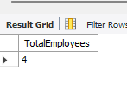
Department-2:
CALL sp_CountEmployeesByDepartment(2);
Output:
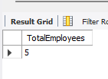
Department-3:
CALL sp_CountEmployeesByDepartment(3);
Output:
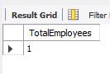
Department-4:
CALL sp_CountEmployeesByDepartment(4);
Output:
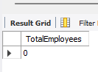

Verify the Table
SELECT * FROM Employees;

Output:
